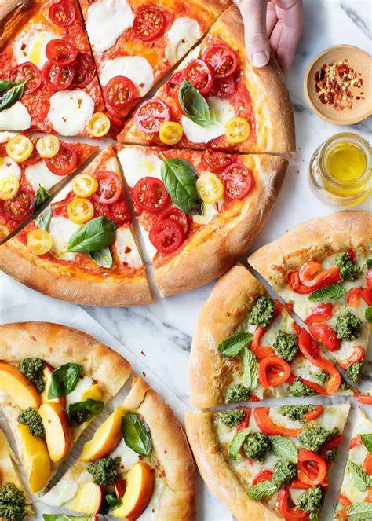

**Author -** [**Anjali**](http://www.linkedin.com/in/anjali-dhull-331549274)

**About the Author**

Anjali is a data enthusiast currently pursuing an M.Sc in applied mathematics

at MNIT Jaipur, India. With a strong foundation in mathematics and computer science, Anjali possesses a particular interest in machine learning and data analysis. He has good knowledge of Python and SQL. He has hands-on experience working with large datasets, cleaning and preprocessing data, and applying statistical and machine-learning techniques.

Anjali aims to apply his knowledge and expertise in data analysis to solve real-world problems, leveraging data-driven approaches for informed decision-making. His enthusiasm for the field drives his motivation to make valuable contributions in understanding and utilizing data effectively

**CONTENTS**

**CONTENTS**

**1. INTRODUCTION**

1.1 OBJECTIVES

1.2 LIMITATIONS

1.3 CHALLENGES

**2. METHODOLOGY**

2.1 DATA COLLECTION

2.2 DATASET DESCRIPTION

2.3 DATA PREPROCESSING

2.4 SCHEMA DIAGRAM

**3. DATA ANALYSIS USING SQL**

3.1 PROBLEM STATEMENTS

3.2 SQL QUERIES USED IN ANALYSIS

**4. DISCUSSION OF RESULTS**

4.1 SUMMARY STATISTICS FROM ANALYSIS

4.2 TALKING ABOUT RESULTS

**5. CONCLUSION**

5.1 OVERALL SUMMARY

5.1.1 Overall Sales Performance

5.1.2 Size and Category Preferences

5.1.3 Best-selling Items

5.1.4 Customer Demand and Order Patterns

5.1.5 Weekly and Daily Trends

5.2 SURPRISING (NOTABLE) CONCLUSIONS

5.3 FINAL WORDS AND SUGGESTIONS

**Chapter-1**

**1.INTRODUCTION**

**1.1 OBJECTIVE**

● The main objective of this project is to identify trends, patterns in the data which can lead to improve revenue and profit

● Gain insights into customer preferences, sales patterns, and key factors influencing pizza sales.

● Understand revenue and profit base by day ,week, month,

● Evaluate sales performance across different pizza sizes and crust types.

● Identify popular pizza combinations and variations.

● Assess the impact of promotional activities on sales volume..

● Determine correlations between specific pizza attributes and revenue and profit

● Uncover potential seasonal or time-of-day trends in pizza sales.

**1.2 LIMITATIONS**

●The analysis assumes that the provided data accurately represents real-world pizza sales and profit and revenue behavior.

● Limited dataset size, which may not capture the entire scope of profit and revenue patterns.

● The analysis is based on a specific dataset, which may not represent the entire population of pizza sales or customer preferences

● Findings should be interpreted within the context of the specific business or industry and may not be universally applicable.

● Different interpretations or perspectives of the results are possible, and alternative explanations should be considered

. **1.3 CHALLENGES**

● Difficulty in identifying and targeting specific customer segments with tailored marketing strategies.

● Limited understanding of the impact of promotional activities on sales volume and customer engagement.

● Inconsistent sales performance across different locations and pizza variations.

**CHAPTER 2**

**2. METHODOLOGY**

**2.1 DATA COLLECTION**

The pizza sales data used in this analysis is collected from Kaggle which is the Data Science

community. The link to the dataset is given below:

[**https://www.kaggle.com/datasets/shilongzhuang/pizza-sales**](https://www.kaggle.com/datasets/shilongzhuang/pizza-sales)

**2.2 DATASET DESCRIPTION**

The dataset contains information about pizza sales, including details such as pizza ID, order ID,

pizza name ID, quantity, order date, order time, unit price, total price, pizza size, pizza category,

pizza ingredients, and pizza name. Each column represents a specific attribute related to the pizza sales data. The dataset encompasses 48621 orders of pizza and customer transactions. This pizza sales dataset is made up 12 relevant features:

● **pizza_id:** The unique identifier for each pizza in the dataset.

● **order_id:** The unique identifier for each pizza order.

● **pizza_name_id:** The identifier for each specific pizza name.

● **quantity:** The number of pizzas ordered in each transaction.

● **order_date:** The date when the pizza order was placed.

● **order_time:** The time at which the pizza order was placed.

● **unit_price:** The price of a single unit of pizza.

● **total_price:** The total price of the pizza order, calculated as the unit price multiplied by the

quantity.

● **pizza_size:** The size or dimensions of the pizza. (S,M,L,XL,XXL)

● **pizza_category:** The category or classification of the pizza, indicating its type or style.

(Classic, Veggie, Supreme, Chicken)

● **pizza_ingredients:** The list of ingredients used in the pizza preparation.

● **pizza_name:** The name or label assigned to each specific pizza.

The screenshot of the first 5 rows of table is given below:

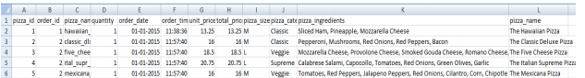

**2.3 DATA PREPROCESSING**

**● Handling Missing Values:** No missing value present in the dataset

**● Removing Duplicates:** No duplicated present in the dataset

**● Checking Data Type of attributes:**

○ orders_date column datatype is incorrect.

○ orders_time column datatype is incorrect .



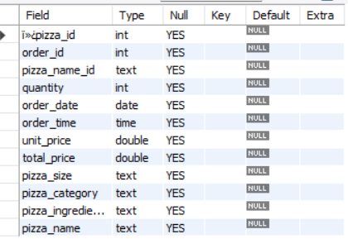

**Changing the datatype of order_date and order_time column:**

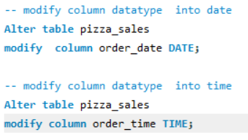

**2.4 SCHEMA DIAGRAM:**

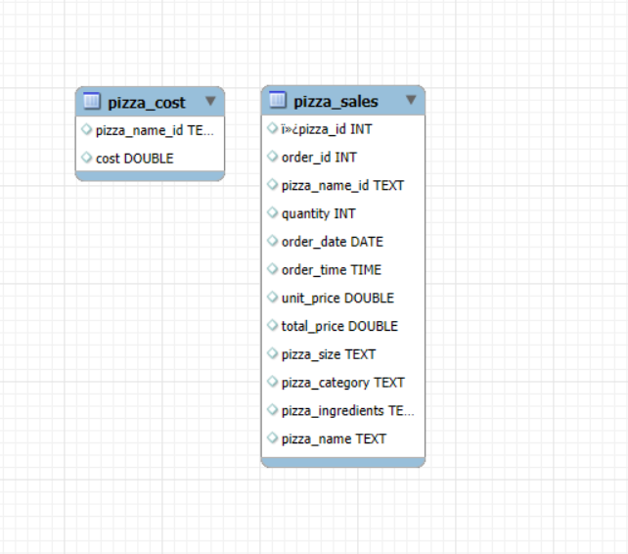

**CHAPTER 3**

**3. DATA ANALYSIS USING SQL**

**KPI’s REQUIREMENT**

We need to analyze key performance indicators for our pizza sales data to gain insights into our business performance. Specifically, we want to calculate following metrics;

1. Total Revenue
2. Total Pizza Sold
3. Total Orders

**SECTOR WISE ANALYSIS**

1. **Sales Performance Analysis**
   1. What is the total revenue of pizza across different categories?
   2. What is the total revenue of pizza across different sizes?
   3. What is the total revenue of pizza across different pizzas?
2. **Seasonal Analysis**
   1. Which days of the week have the highest number of orders?
   2. Which month has the highest revenue?
   3. Which season has the highest revenue?
   4. Which month has the highest Profit?
   5. Which Time of day gives the highest Profit?
3. **Profit Analysis**
   1. Which pizza gives the highest profit?
   2. Profit by Category.
4. **Pizza Analysis**
   1. The pizza with the lowest price and highest price.
   2. Number of pizzas sold.
   3. Different types of pizzas category?
   4. How many different types of pizzas?

## **3.2 SQL QUERIES USED IN ANALYSIS**

**KPI’s REQUIREMENT**

* **Total Revenue:**

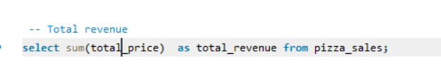



The Total Revenue of the pizza sales is **$ 817,860.**

* **Total Pizzas Sold**

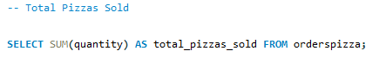



Total Pizzas Sold are **49,574**

* **Total Orders**



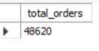

There are **48620** orders placed by customers

**Sales Performance Analysis**

What is the total revenue of pizza across different categories? 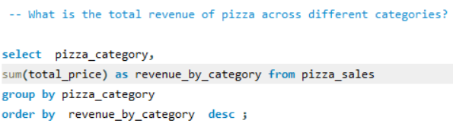

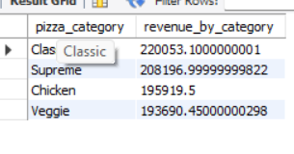

What is the total revenue of pizza across different sizes?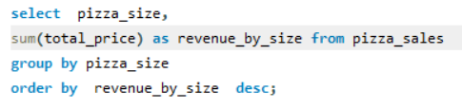

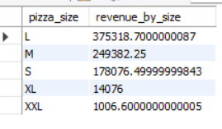

which type of pizza( name ) has highest revenue

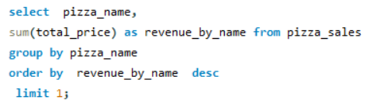



* **Seasonal Analysis**

Which days of the week have the highest number of orders?

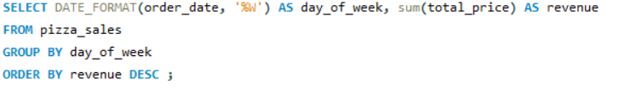

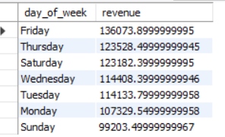

Which month has the highest revenue?

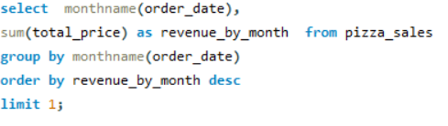

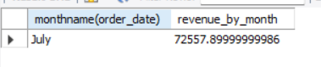

Which season has the highest revenue?

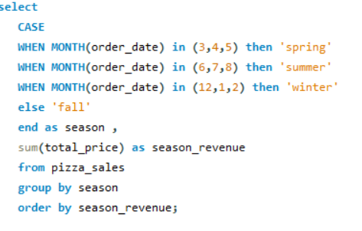

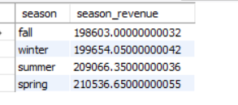

Which month has the highest Profit?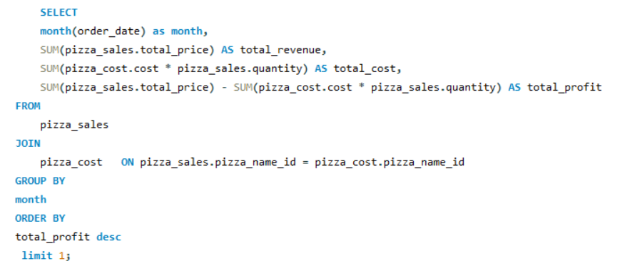

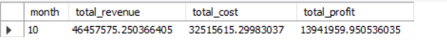

Which Time of day gives the highest Profit?

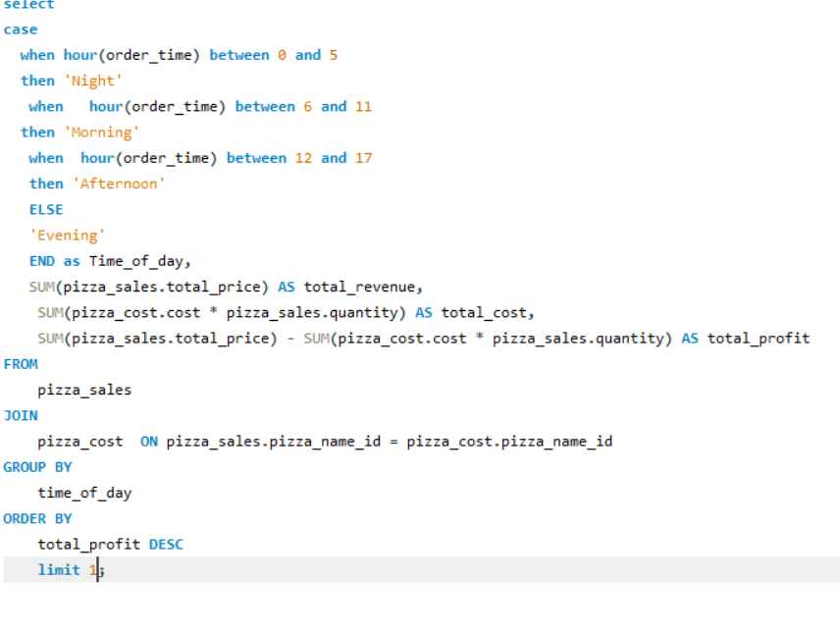



* **Profit Analysis**

Which pizza gives the highest profit?

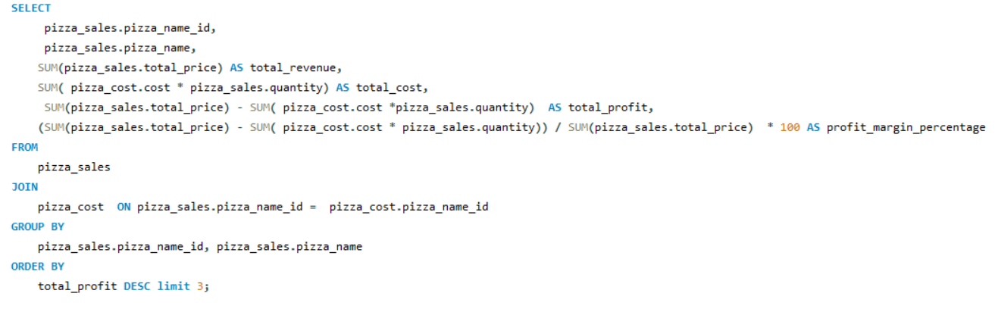

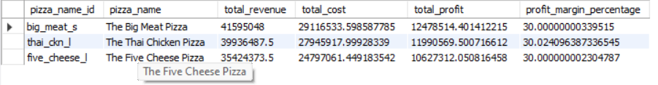

Profit by category

* **Pizza Analysis**

Thepizza with the lowest price and highest price.



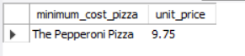

Number of pizzas sold 



Different types of pizzas category?

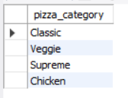

How many different types of pizzas?



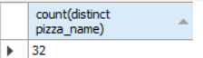

**CHAPTER 4**

**4. DISCUSSION OF RESULTS**

## **4.1 SUMMARY STATISTICS FROM ANALYSIS**

* **The KPI’s Requirement is tabular format:**

| **Metric** | **Value** |
| --- | --- |
| Total Pizza’s Sold | 49,574 |
| Total Revenue | $ 817,860 |
| TotalCategory | 4 |
| Total different pizza’s | 32 |
| Total orders | 48,620 |

* **Highest and Lowest Revenue & Profit Generator Categories:**

| **Category** | **Highest Revenue** | **Lowest Revenue** | **Highest Profit** | **Lowest Profit** |
| --- | --- | --- | --- | --- |
| Pizza | The thai chicken pizza  $ 43,434 | The brie carre pizza  $11,588 | The big meat pizza  $12,478,514 | The Greek pizza  $ 8,459 |
| Pizza size | L  $ 375,318 | XXL  $ 1006 | L  $ 91937845 | XXL  8459 |
| Pizza category | Classic  $ 220,053 | Veggie  $ 193,690 | Classic  $51,973,441 | Supreme  $37,155,791 |

* **Seasonal Revenue Analysis Statistics:**

| **Category** | **Highest**  **Revenue** | **Lowest Revenue** |
| --- | --- | --- |
| Day of  week | Friday  $ 136,073 | Sunday  $99,203 |
| Month | July  $ 72,557 | October  $ 64,027 |
| Season | Spring  $ 210,536 | Fall  $ 198,603 |

* **Pizza Analysis Statistics:**

| **CATEGORY** | **HIGHEST**  **PRICE** | **LOWEST**  **PRICE** |
| --- | --- | --- |
| Pizza | **The Greek Pizza**  ($ 35.95) | **The Pepperoni Pizza**  ($ 9.75) |
| Month | **July**  $15,885,408 | **October**  $13,941,959 |

**4.2 TALKING ABOUT RESULTS**

* This dataset contains information about pizza sales in 2015.
* Large size pizzas are preferred over other sizes.
* Classic category pizzas are preferred over other categories.
* The Classic category is the most popular and best-selling category.
* The Classic Deluxe pizza is the top-selling item.
* Large size pizzas have the highest demand and popularity.
* The Brie Carre Pizza is the least selling pizza.
* The pizza shop is usually busy during lunch and dinner hours.
* The number of orders is high on Fridays.
* The Big Meat Pizza is the most frequently ordered item.
* Large size pizzas are the most commonly ordered.
* Classic category pizzas are the preferred choice.
* Greek Pizza is very costly.
* Highest Profit earn in the month of July.

**CHAPTER 5**

**5. CONCLUSION**

## **5.1 OVERALL SUMMARY**

### **5.1.1 Overall Sales Performance**

During the analyzed period of 2015, the pizza sales performance demonstrated strong results. The total revenue generated amounted to $817,860, with a significant number of pizzas sold, reaching 49,574. This indicates a healthy demand for pizzas during this period.

### **5.1.2 Size and Category Preferences**

### Customers displayed a strong preference for large-sized pizzas, indicating a preference for sharing or group occasions. The Classic category emerged as the most preferred among customers, solidifying its popularity and demonstrating its ability to cater to a wide customer base.

### **5.1.3 Best-selling Items**

The Classic Deluxe pizza stood out as the best-selling item, consistently outperforming other menu options. This pizza's unique flavor and combination of ingredients resonated well with customers, contributing to its popularity.

### **5.1.4 Customer Demand and Order Patterns**

### The demand for large-sized pizzas highlights customer preferences for larger portions, potentially for social gatherings or shared meals. The Brie Carre Pizza had the least sales, indicating a lower appeal among customers.

**5.1.5 Weekly and Daily Trends**

Fridays experienced a significant surge in the number of orders, suggesting increased sales activity at the end of the workweek.

## **5.2 SURPRISING (NOTABLE) CONCLUSIONS**

* **Sunday as the Least Busy Weekday**: Sundays exhibit lower customer activity compared to other weekdays, suggesting that the shop's main customer base consists primarily of working individuals. Many people may prefer to dine out or order pizza during the weekdays due to their busy schedules.
* **Seasonal Sales Patterns**: Spring season experiences higher sales compared to other seasons, while sales during the fall season are relatively lower. This could be influenced by various factors such as weather, seasonal events, or cultural preferences during different times of the year.
* **Preference for Large Size**: The most preferred pizza size by customers is large. This indicates a tendency for customers to order pizzas in groups, potentially for sharing among family, friends, or colleagues.
* **The Thai Chicken Pizza**: Although the Thai Chicken Pizza generates the highest revenue per unit price, it falls under the least available category. This indicates that there is a niche market or specific customer segment that highly values this unique pizza flavor, leading to a higher willingness to pay for it.
* **Classic Category Dominance**: The Classic category emerges as the most Profitable, highest revenue-generating, and most available pizza category. This popularity could be due to the timeless appeal and widespread recognition of classic pizza flavors, making them a go-to choice for customers.
* **The Big Meat Pizza**: This pizza stands out as the most Profitable item, indicating a high demand for its combination of meat toppings. Despite not belonging to the highest revenue-generating category, its popularity suggests a strong preference for this specific flavor profile.

## 

## 

## 

## 

## 

## **5.3 FINAL WORDS AND SUGGESTIONS**

The analysis of the pizza sales data has provided valuable insights into customer preferences, order patterns, and revenue generation. The findings indicate that the pizza shop attracts a diverse customer base, including working individuals and school students. The popularity of large-sized pizzas suggests that customers often come in groups or seek convenient meal options for gatherings. The Classic category stands out as the preferred choice among customers, showcasing the timeless appeal of classic pizza flavors. Additionally,The Thai Chicken Pizza and the Big Meat Pizza, featuring the popular chicken topping, have emerged as top sellers, showcasing the importance of incorporating well-balanced flavor profiles that include chicken.

Considering the analysis results, the pizza shop can consider the following suggestions to further improve its business:

* **Menu Optimization**: Based on the popularity of large-sized pizzas and the Classic category, the pizza shop can focus on expanding its offerings in these areas.
* **Marketing Strategies:** Leveraging the insights gained from peak order times, such as the lunchtime and dinnertime rush, the pizza shop can implement targeted marketing campaigns to attract customers during these busy periods.
* **Menu Recommendations**: Based on the analysis, highlighting the best-selling and unique pizzas like the Classic Deluxe and the Thai Chicken Pizza can attract customer attention. Displaying these recommendations prominently on menus and promotional materials can increase their visibility and encourage customers to try these popular options.